**Project Planning Phase**

**Project Planning Template (Product Backlog, Sprint Planning, Stories, Story points)**

|  |  |
| --- | --- |
| Date | 21 Nov 2023 |
| Team ID | 591647 |
| Project Name | Project - **Machine Learning Approach For Predicting The Rainfall** |
| Maximum Marks | 8 Marks |

**Product Backlog, Sprint Schedule, and Estimation (4 Marks)**

Use the below template to create product backlog and sprint schedule

|  |  |  |  |  |  |  |
| --- | --- | --- | --- | --- | --- | --- |
| **Sprint** | **Functional**  **Requirement (Epic)** | **User Story**  **Number** | **User Story / Task** | **Story Points** | **Priority** | **Team**  **Members** |
| Sprint-1 | **Data Acquisition and Preprocessing** | USN-1 | As a data scientist, I want to collect historical meteorological data for training the rainfall prediction model.  As a data engineer, I want to clean and preprocess the collected data to remove outliers and handle missing values. | 5 | High | Akash |
| Sprint-2 | **Model Development** | USN-2 | As a machine learning engineer, I want to choose and implement a suitable machine learning algorithm for rainfall prediction | 8 | High | sahith |
| Sprint-3 | **Model Evaluation and Fine-Tuning** | USN-3 | As a machine learning engineer, I want to fine-tune hyperparameters to improve the model's accuracy after the splitting of data into testing and training. | 6 | Medium | Leela Krishna |
| Sprint-4 | **Model Interpretability and Explainability** | USN-4 | As a stakeholder, I want a clear understanding of how the rainfall prediction model makes its predictions. | 7 | Medium | Akash |
| Sprint-5 | **Deployment and Integration** | USN-5 | As a system administrator, I want to deploy the trained model into a real-world environment and integrate it with existing systems. | 10 | High | Sahith |
|  |  |  |  |  |  |  |
|  |  |  |  |  |  |  |
|  |  |  |  |  |  |  |

**Project Tracker, Velocity & Burndown Chart: (4 Marks)**

|  |  |  |  |  |  |  |
| --- | --- | --- | --- | --- | --- | --- |
| **Sprint** | **Total Story Points** | **Duration** | **Sprint Start Date** | **Sprint End Date (Planned)** | **Story Points**  **Completed (as on**  **Planned End Date)** | **Sprint Release Date (Actual)** |
| Sprint-1 | 5 | 6 Days | 01 Nov 2023 | 07 Nov 2023 | 30 | 21 NOV 2023 |
| Sprint-2 | 8 | 7 Days | 07 Nov 2023 | 14 Nov 2023 |  |  |
| Sprint-3 | 6 | 6 Days | 14 Nov 2023 | 20 Nov 2023 |  |  |
| Sprint-4 | 7 | 6 Days | 15 Nov 2023 | 21 Nov 2023 |  |  |
| Sprint-5 | 10 | 5 Days | 16 Nov 2023 | 21 Nov 2023 |  |  |
|  |  |  |  |  |  |  |

**Velocity:**

Imagine we have a 10-day sprint duration, and the velocity of the team is 20 (points per sprint). Let’s calculate the team’s average velocity (AV) per iteration unit (story points per day)

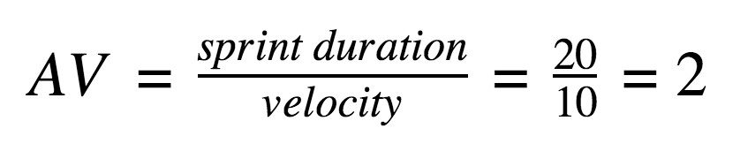

AV=30/36=0.83

**Burndown Chart:**

A burn down chart is a graphical representation of work left to do versus time. It is often used in agile [software development](https://www.visual-paradigm.com/scrum/what-is-agile-software-development/) methodologies such as [Scrum.](https://www.visual-paradigm.com/scrum/scrum-in-3-minutes/) However, burn down charts can be applied to any project containing measurable progress over time.

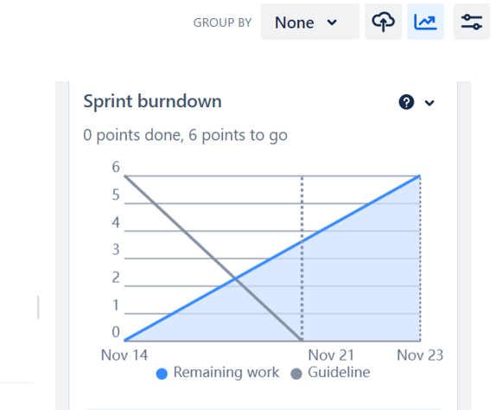

**Board Section**

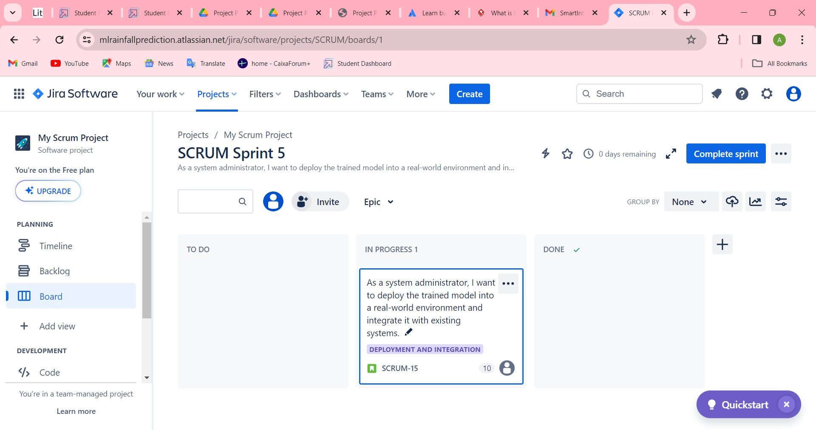

**Backlog Section:**

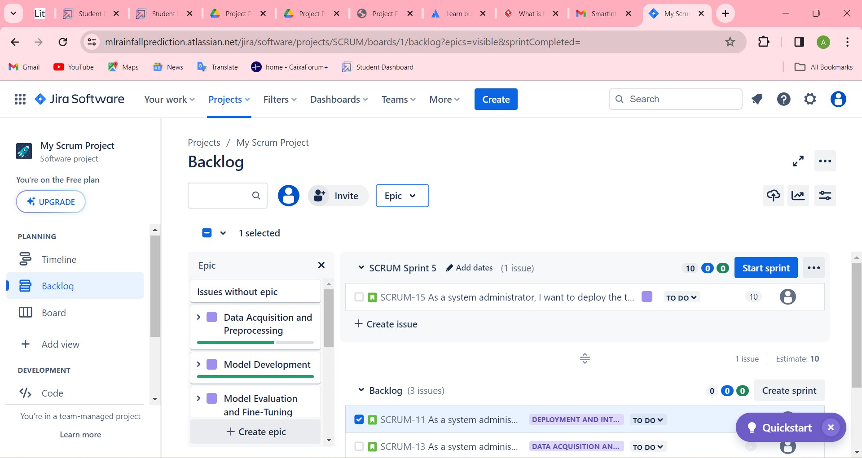

**Timeline:**

